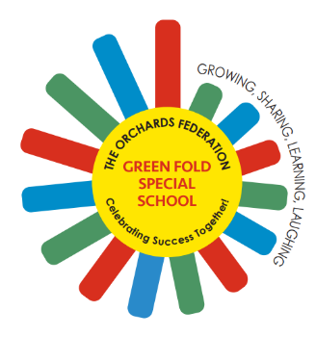

Green Fold Specialist School

An Orchards Federation Provision

Teaching Assistant Level 1
Key Information
Start date: September 2026 or sooner

Telephone: 01204 335 883 Email: office@theorchards.bolton.sch.uk

www.greenfold.bolton.sch.uk

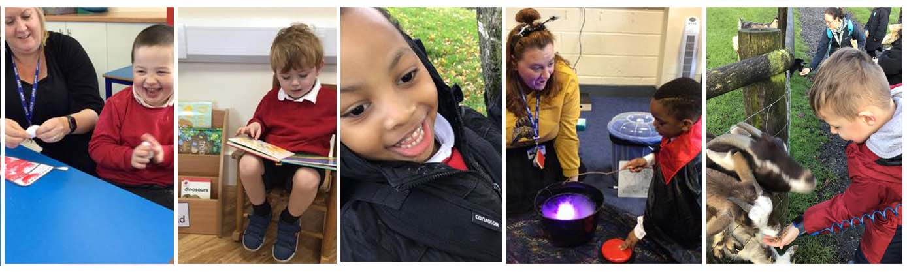


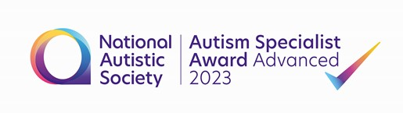

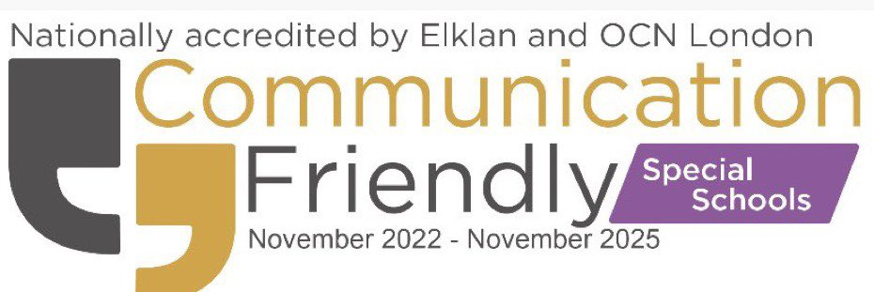

Contents

- Welcome and overview
- School Vision and Mission Statement
- School Curriculum
- School Partnerships
- Learning Environments for All
- Family Support
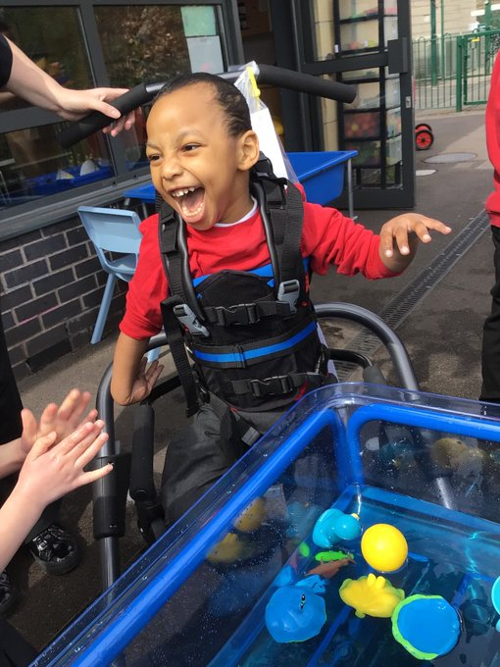
- Care and Safeguarding
- External Quality Assurance

Welcome to Green Fold School!

Dear Applicants,

As Headteacher, it is my privilege to provide a key over view to Green Fold School – a super special school for super special children in the heart of Bolton. Due to expansion we are currently seeking to appoint additional TA Level 1 staff.

We have positions including:

- 30.46 hours per week term time +5 days
- 20 hours per week term time (4 hours per day between 8.45 and 3.15 to be specified by school)

Green Fold is a maintained primary special school that provides the highest quality of education for over 170 children aged 4-11 with a wide variety of highly complex needs including PMLD, SLD and Autism with a range of associated communication, interaction, social, sensory and learning differences.

Our team consists of over 140 school-based practitioners in education, health and care who work tirelessly to ensure that we offer the best holistic education and care to our students and support to their families and the wider community.

Our school is part of The Orchards Federation, a group of three schools working closely together for the benefit of all our pupils, the other members of the Federation are The Orchards Nursery School and Cherry Tree Primary School.

Green Fold is located across 4 sites in Bolton each with specific enabling learning environments closely matched to our learners needs.

In 2025/26 our educational offer is organised in the following way:

- The Seedlings provision in Daubhill is the home to our Early Years team, a bespoke provision meeting the needs of our children as they enjoy a bright start on their journey with us.
- Our Saplings provision on Lever Edge Lane caters for autistic children in Key Stage 1 and Lower Key Stage 2
- The Orchards Upper Site in Farnworth provides for children with Autism, SLD and PMLD and includes resources such as our hydro pool and full tracking hoists into the classrooms for our PMLD learners who require this support.
- At the Orchards Lower Site in Farnworth our provision is focussed upon support for our learners with autism in Key Stage 2.

Each of our buildings have excellent facilities and all are equipped with new high specification sensory rooms and other specialist spaces.

We are proud to be recognised as outstanding practitioners in PMLD and complex needs education and are additionally the Autism Education Trust providers for Bolton - we ensure our children are always at the forefront of evidence-based learning.

Green Fold is a place where each pupil is allowed to express themselves as individuals and learn in a style that best meets their needs.

‘Pupils love coming to Green Fold School. It is a place where all pupils flourish.’ Ofsted November 2023

As a Federation we focus strongly on staff and children’s wellbeing. We can offer you an excellent opportunity to continue your professional development, where you will receive a high level of commitment and support from staff, governors and families.

This is a particularly exciting time to join the school as we continue to expand with projected numbers exceeding 185 by 2026. Green Fold and The Orchards Federation are currently undergoing significant building works at all sites to ensure the provision is fit for the future.

Our website is currently being updated to reflect changes within our Federation so please do contact us in person with regard to any queries.

We hope you find this pack informative and are keen to know more!

Advert closes – Monday 27th April 2026 at 9am

Interviews- Thursday 30th April 2026 and Friday 1st May 2026

Kind regards,

Lisa

Mrs. L. Walker
Headteacher



Our Mission & Values

As part of the Orchards Federation of Schools we share a joint vision of creating opportunities for everyone to succeed.
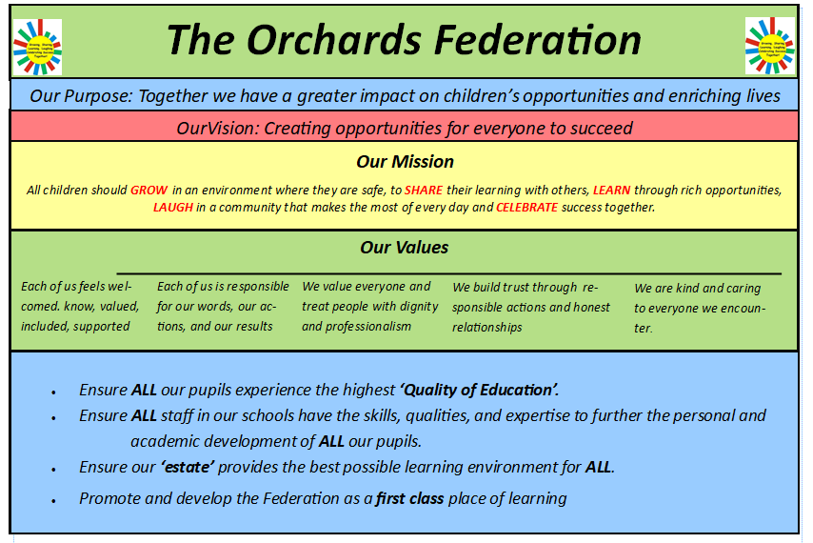

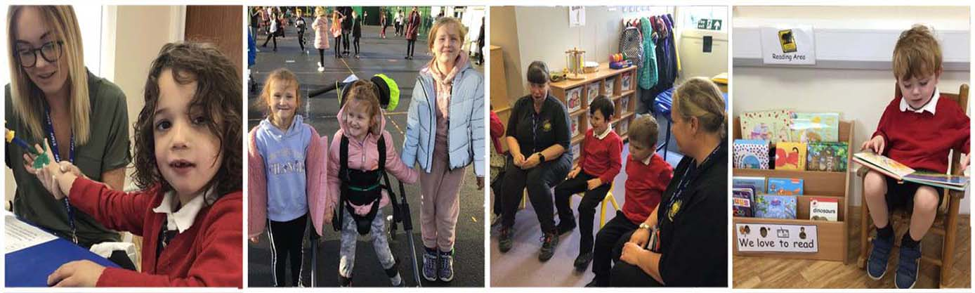

Green Fold School Curriculum

Our curriculum at Green Fold School provides an opportunity for each child to reach their potential.

All pupils at Green Fold School have severe learning difficulties and highly complex needs working significantly below age related expectations and key stage standards - and therefore have the right to a modified curriculum to allow them to have an educational provision that accurately meets their needs. This is achieved by planning work that closely links to each child’s Education Health and Care Plan (EHCP).

Pupils’ learning styles are carefully considered. We strive to develop stimulating learning environments outside the confines of the classroom, promoting learning through positive outdoor experiences and play.

Through a broad, balanced and sequential program of studies, the curriculum at Green Fold School is designed to give all learners the knowledge and cultural capital they need to develop and maximise their independence and lead a successful and joyful life.

Our ambitious context and skill based curriculum extends beyond the academic and provides for learners’ broader development, we place equal emphasis on all areas of our Core Curriculum:

- Communication
- Development of Life Skills
- Academic (Cognition and Learning)
- Therapeutic Support led by our OT, Physio, SALT and school nursing teams.

Each area of our curriculum is personalised to meet the needs of each student providing rich opportunities for linked learning to prepare them for the next stage of their education and life beyond school and enable them to flourish and thrive.

‘From children in early years to the oldest pupils, there is no ceiling placed upon what staff want pupils to achieve. Staff have a thorough understanding of pupils’ unique and complex needs. This, along with an aspirational curriculum, ensures that pupils, all of whom have special educational needs and/or disabilities, are exceptionally well prepared for their next steps in education’. Ofsted, November 2023.

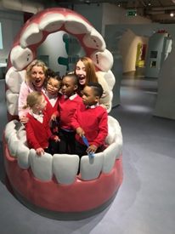
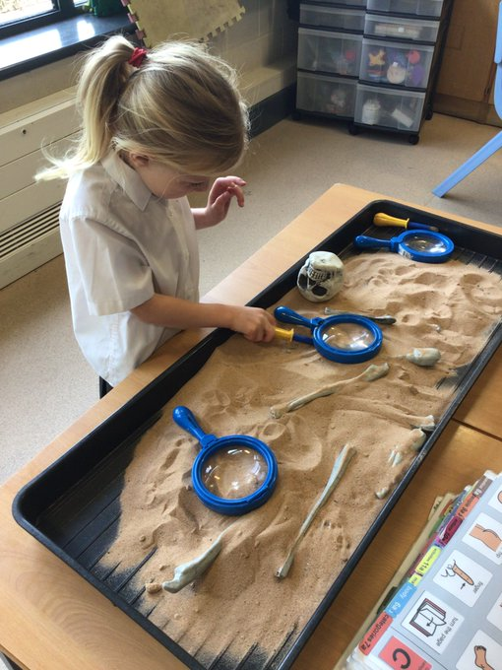
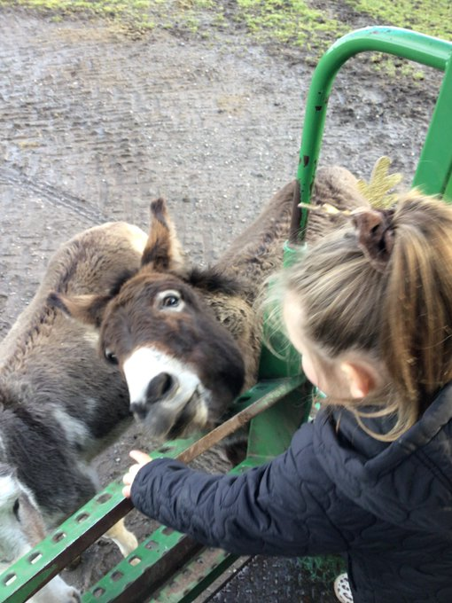

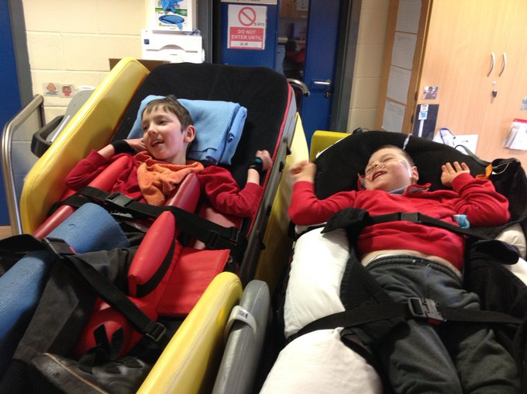

School Partnerships

All of our learners have an Education, Health and Care Plan (EHCP) on entry to Green Fold School.

We work closely with our school based highly skilled paediatric multidisciplinary team (MDT) of NHS and private practitioners including Speech and Language Therapy (SALT), Occupational Therapy, Physiotherapy, Hearing and Visual Impairment teachers, School Nursing and Education to develop and implement a pupil specific therapy plan to support the specialist education provision and health care provision initially identified in the EHCP or at a later point.

Our therapists work closely with the children to support them in each specialised area and additionally provide guidance, training and quality assurance to our class-based education teams in specific areas to enable learning to be embedded within the school day.

Classrooms are well equipped to support therapy work and we additionally have a suite of specialist spaces.

Please do visit our website to view the full range of therapies offered and to meet our Multi-Disciplinary Team.

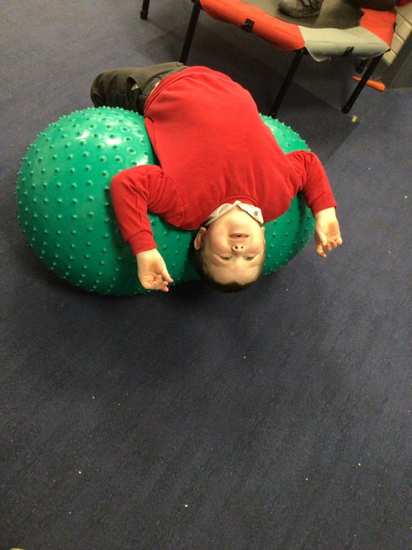

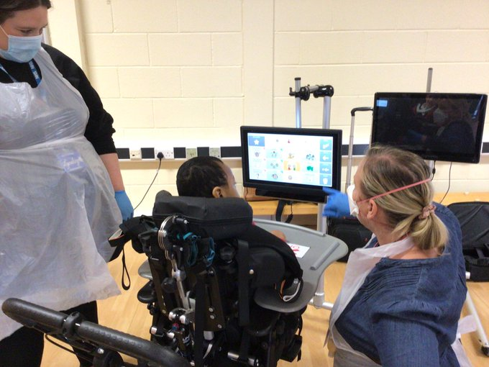

Learning Environments for All

Our learning environments reflect student needs in terms of specific classroom resources, space and timetabling. We use evidence-based approaches to inform our decisions on our classroom facilities including seeking advice from our MDT and wider professional bodies including the NAS and PMLD Frameworks.

Adaptions include for example consistent use of visual communications in every class following our Total Communication Approach, increased sensory equipment as appropriate and the use of workstations for learners who benefit from 1:1 focussed spaces as well as access to smaller group or individual work spaces and access to continuous provision and outdoor learning spaces. Specialist pedagogies such as Attention Autism are embedded within each class.

Our facilities also include several multi-sensory spaces, a rebound suite, an immersive classroom, multiple sports halls, outdoor play areas and a well-equipped hydrotherapy pool for those children who require this support.

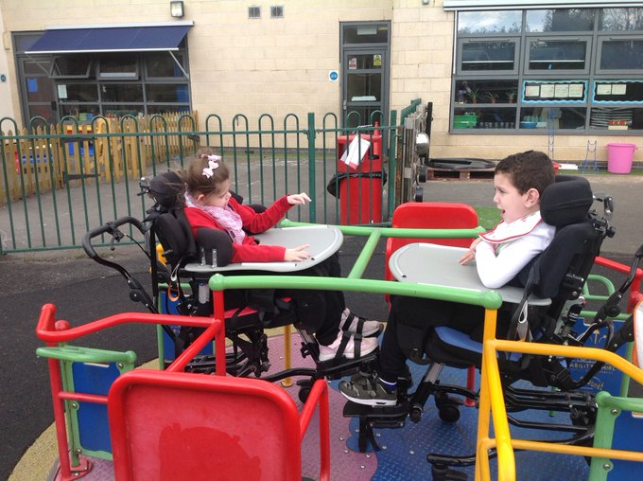

Family Support

We recognise and value that parents know their child better than anyone else and play a key role in sharing, developing, and implementing strategies in a range of environments.

We communicate with parents on a daily basis using our Dojo Messaging service and create regular opportunities for families to come into school and share learning opportunities with their children – from Christmas parties to classroom story sessions, we aim to work closely with families at all times and encourage frequent communication. Parents can message class teachers and members of our therapy team including Speech and Language therapists directly.

A vibrant parent group is established at Green Fold. Meeting each half term the group gather informally for coffee and conversation. Regular guests include Headteacher as well as professionals from Speech and Language, Health and Care.

Additionally, we provide a wide range of specialist workshops delivered by key practitioners from education, health and care to further enhance all of our skillsets to provide the highest levels of care for children. The latest events can be found on our website and are free of charge to Green Fold Families.

Our PTA ‘Friends of Green Fold’ meet each calendar month to raise funds for the school whilst having fun together – families, staff and children all enjoy the activities including Park Runs, School Fairs and sponsored events.

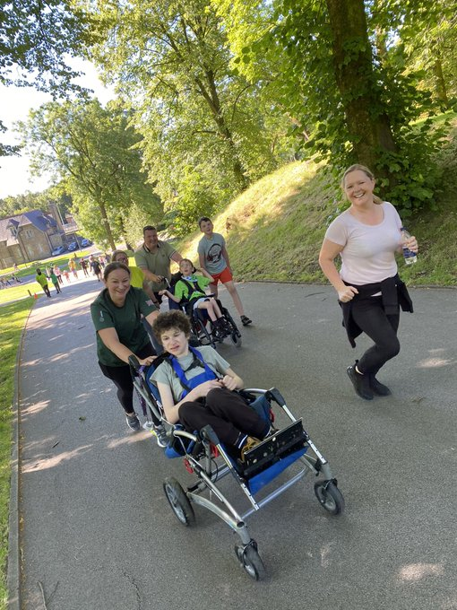
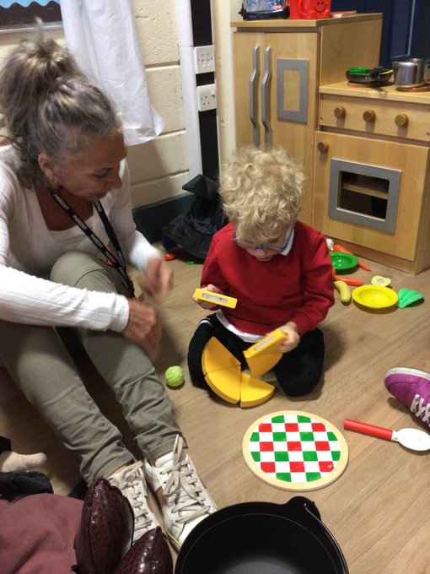

Care and Safeguarding
Safeguarding is paramount at Green Fold School. All of our staff are subject to a stringent safer recruitment process and have enhanced DBS. We are committed to working with families and other agencies to promote the safety and wellbeing of all pupils. All of our staff are trained in Keeping Children Safe in Education.

We also have a dedicated Children and Families team who have two core functions;

- Ensure all children at Green Fold School stay safe, well and happy
- Offer advice and support to families – current, prospective and past

Our Children and Families team are fully trained Designated Safeguarding Leads. Parents can contact our Children and Families team directly and in confidence via DoJo or telephone.

Due to our day-to-day contact with children, schools are particularly well placed to observe outward signs of abuse, changes in behaviour or failure to develop. Parents should be aware therefore, that where it appears to a member of staff that a child may have been abused, the school is required, as part of local Child Protection Procedures, to report their concern to the Social Services Department immediately.

Consequently, in such situations, it is likely that a social worker, not the school will contact the parents.

This requirement forms part of the local authority's procedures for dealing with child protection and is not a matter for the discretion of the Head Teacher or members of the school staff.

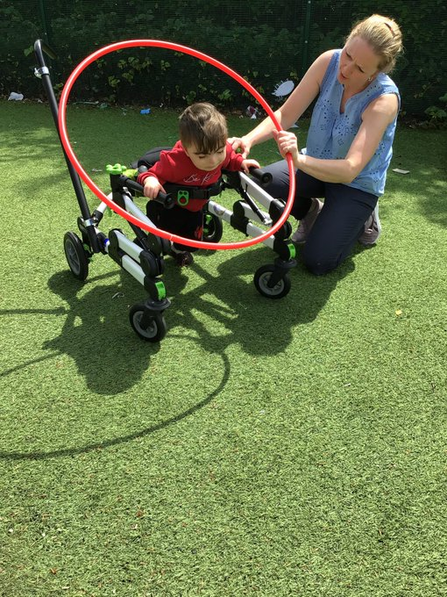

External Quality Assurance

Green Fold School has a culture of continual school improvement – we seek to achieve the highest standards for our children at all times. Current independent measures of the school’s effectiveness against local and national standards include:

- Ofsted Outstanding Provider – December 2008, March 2012, November 2016, May 2022, November 2023
- National Autistic Society Accredited – 2019, National Autistic Society Advanced 2023
- Elklan Communication Friendly Specialist Setting Award
- Educate Awards Most Inspirational Primary School 2024
- National Healthy Schools Award
- Eco Schools Award
- Autism Education Trust training provider for Bolton
- School Games Gold Award
- Schools of Sanctuary Award



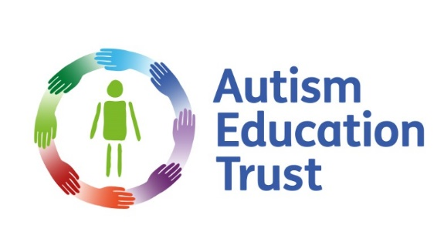
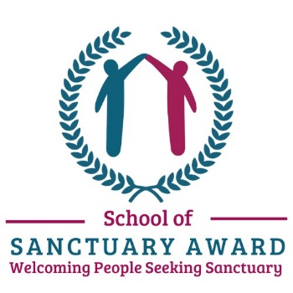

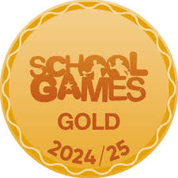
Contact Information

We hope you have found this overview informative and keen to know more.

Our website contains further core practical information including times of the school day, uniform requirements, school meals, transport arrangements, governance, key policies and procedures and up to date staff lists including practitioners and key contacts in education, health and care.

We have active social media accounts on Facebook, Instagram and Twitter – please do follow us for regular updates and a window into our world.

Please do feel free to contact our team via office@theorchards.bolton.sch.uk with any questions or telephone 01204 332 680.

Website: www.greenfold.bolton.sch.uk
Facebook: @GreenFoldSpecialSchool
X (Formerly Twitter): @GreenFoldSchool
Instagram : @GreenFoldSchool

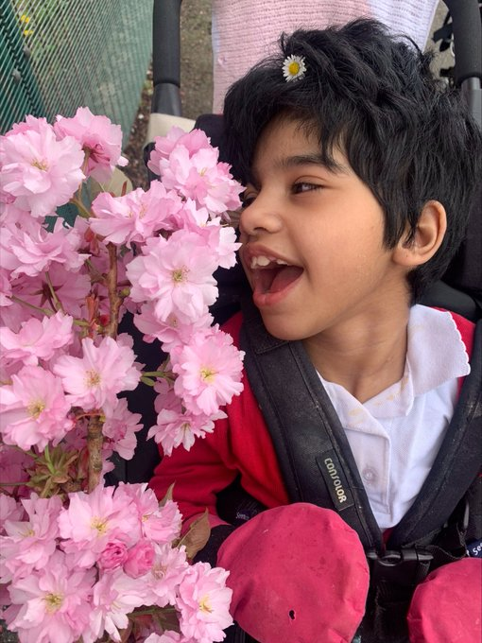
The Seedlings
Green Fold School, Martha Street, Daubhill, Bolton. BL3 4AH

The Saplings
Green Fold School, Lever Edge Lane, BL3 3HH

The Orchards Lower Site
Green Fold School, Highfield Drive, Farnworth, Bolton. BL4 0RA

The Orchards Upper Site
Green Fold School, Highfield Road, Farnworth, Bolton. BL4 0NS

