**Rumworth School**

**Two Permanent Teaching Assistants Level 1**

**(Grade D Scale Point 6 to 11)**

**Required as soon as possible**

**Employer:** Bolton Council  
**Location:** Bolton  
**Salary:**  £25,183 (Point 6) to £27,269 (point 11), pro rata £18,942 to £20,511

**Salary Grade:** Grade D

**Working Pattern:**Term time plus 5 days  
**Working Hours:**32.5 hours weekly

**Contract Type:** Permanent

**Closing Date:**10:00 am on Thursday 23rd January 2025  
**Job Type:** Education School based, Teaching Assistants  
**Interview Date:** Week beginning Monday 27th January 2025, exact date & timings TBC

We are looking to recruit two permanent TA1 Teaching Assistants in order to meet specific student needs across school, which may include providing general support for students in either KS3, KS4 or KS5.

Rumworth School is a highly regarded Local Education Authority maintained special school in Bolton with an excellent reputation for providing an outstanding provision for all students. Visitors to our school always comment on the “lovely feeling and buzz” and the calm & purposeful learning environment. We currently cater for a range of learning difficulties and additional needs for around 340 students, with a planned building expansion programme to offer 400 places. Our students are aged 11-19 and they all have an EHCP because they have a range of SEND which may include: Moderate and Severe Learning Difficulties, Complex Needs, Autistic Spectrum Conditions, Hearing and Visual Impairment, Physical Disability and Social, Emotional and Mental Health Needs. What our students most definitely do all have is a wonderful sense of fun, a love of learning, a high regard for each other and the adults who work with them, and they can’t wait to meet you!

Our ethos is “Start with the young person” therefore you will be a champion for education as the vehicle to improve the life chances and outcomes for our students. Our vision is “You can do it, we will help” - in order to meet the needs of our students, we do have small teaching group sizes and high adult to student ratios. As a form teacher, you will embody our philosophy of supporting young people to be more “Confident, Resilient and Independent” through our rich offer of wider life experiences and activities.

Year 7 operates as a “Foundation Year” where students have a more class-based transition from their primary school with the Year 7 team delivering the majority of learning. Year 7 students also access specialist rooms including our dedicated Science laboratories, and they are taught by specialist subject teachers for lessons such as Science, Design Technology, Forest School, Art, Music, PE and ICT.

Students in Years 8 to 11 then follow a differentiated curriculum model, according to their needs:-

* Some follow a more formal curriculum with a modified mainstream approach
* Some have less transition and spend more time on the consolidation of basic skills in a based class

All students access appropriate external accreditation at the end of KS4 and during KS5, and our full accreditation offer includes GCSEs, ASDAN, BTEC, Functional Skills and Entry Level Certification, dependent upon subject and student ability. In KS5, students continue to follow the most suitable curriculum for their ability. We offer a Year 14 Transition where some students continue on to the “Pathway to Employment” route, and those with SLD and complex needs would usually follow a “Pathway to Independence” route.

We are always keen to recruit staff of the highest calibre, and what matters most to us is that you are the “right fit” for our students. We do have some degree of internal flexibility when it comes to the age range you would be most keen to work with and the type of student needs that you have experience with. We welcome applications from people with mainstream experience, and those with SEND special school experience. Please note that we do expect applicants to be able to demonstrate that they have good personal skills in numeracy, literacy and ICT, and these may be assessed during the interview process.

**Visits to our school:**

Visits are strongly recommended prior to application, as this is helpful when tailoring a letter of application in order to evidence how you best meet the selection criteria. Please do not send a generic letter or a CV with your application.

Please contact our School Office on 01204 333600 in order to arrange a visit.

**How to apply:**

Please download and complete the application form and outline your suitability for this post at Rumworth School in your letter of application, within a maximum of two sides of A4 paper.

This post is also advertised on the “Current Vacancies” tab on our school website, and can be found at http://www.rumworth.co.uk/vacancies

All applications should please be returned electronically to Mrs Marsha Andrews, the Headteacher’s PA: mandrews@rumworth.bolton.sch.uk

**Closing date:** 10:00 am on Thursday 23rd January 2025

**Shortlisting:** Friday 24th January 2025

Shortlisted candidates to be informed by 3:00 pm on Friday 24th January 2025

**Interview Date:** Week beginning Monday 27th January 2025, exact date & timings TBC

We are committed to safeguarding and promoting the welfare of children and young people, therefore as part of our Safer Recruitment process, references will be requested for all shortlisted applicants.

Appointments are also subject to the outcome of an enhanced DBS check and being able to provide evidence of your qualifications.

Rumworth School, Armadale Road, Bolton BL3 4TP

Telephone: 01204 333600

**Rumworth School**

**Permanent Teaching Assistant Level 1 (Grade D)**

**Applicant Information Pack**

|  |  |
| --- | --- |
| **Our Ethos** | **START WITH THE YOUNG PERSON** |
| **Our Vision** | **‘YOU CAN DO IT, WE WILL HELP’**  Supporting young people to be more  Confident, Resilient, Independent |
| **Our Inclusion Principles** | **EQUALLY DIFFERENT, DIFFERENTLY EQUAL**  At Rumworth, everyone is valued and welcomed as belonging to our school community. Difference and diversity are accepted and nurtured  as contributing to all our achievements. We foster participation and  mutual respect as part of everyday life in our school |
| **Our Mission** | We believe that everything we do should start with the young person.  For them, we aim to create a happy, safe and effective learning community, in which all stakeholders are valued. We aim to provide our students with a wealth of learning opportunities which will not only give them an enriching school experience, but will also equip our students with the skills to give every young person the chance to progress smoothly towards a life of opportunity. |

**Rumworth School**

**Teaching Assistant Level 1 (Grade D)**

**Permanent post**

**Job Description**

**Job Title** Teaching Assistant Level 1

**Grade** Grade D

**Primary Purpose of the Job**

Work with and supervise individual students and groups of students under the direction/instruction of teaching & / or senior staff, inclusive of physical & general care and basic classroom management.

**Responsible to**: Headteacher / Line manager

**Principal Responsibilities**

Provide support for students, teachers, the wider curriculum and the school, including supporting students with feeding, intimate care and mobility needs

**MAIN DUTIES**

**1. Support for students**

a. Establishing good working relationships with students, acting as a role model

b. Being aware of and responding appropriately to individual student needs

c. Promoting inclusion and acceptance of all students

d. Encouraging students to interact with others and engage in activities led by the teacher

e. Encouraging students to act independently, as appropriate, including:

Assisting students to eat their lunch, in accordance with training provided for any who need particular help or aids, or who need feeding.

Toileting and changing students including appropriate use of equipment to assist with manual handling in line with guidance and training received.

f. Supervising students during break and at lunchtime being aware of individual behavioural strategies.

g. Supporting students who become ill during the day, under the direction of appropriate staff

**2. Support for teachers**

a. Provide minimal clerical / administration support (e.g. photocopying, filing, collecting money etc.)

b. Assisting with the display of children’s work

c. Preparing areas of school for activities and clearing afterwards

d. Reporting student achievements, progress and issues as appropriate in the agreed format

e. Undertaking student record keeping as requested

f. Managing student behaviour in line with school policy and ensure behaviour reports are made in the agreed school format

g. Gathering / reporting basic information from / to parents / carers as directed

**3. Support for the wider curriculum**

a. Assisting students to access their wider curriculum by meeting their care, intimate care and mobility needs under the direction and guidance of other professionals

b. Preparing and maintaining equipment and resources as directed, including cleaning specialist chairs, doing laundry, etc.

**4. Support for the school**

a. Be aware of and comply with school policies and procedures relating to safeguarding & child protection, health, safety and security, confidentiality and data protection. Report all concerns to the appropriate person (as named in the policy concerned)

b. Contribute to the school ethos, aims and development/improvement plans

c. Appreciate and support the role of other professionals

d. Attend relevant meetings as required

e. Participate in training and other learning activities as required

f. Assist with the supervision of students out of directed lesson time, including before and after school if appropriate and within working hours

g. Accompany teaching staff and students on visits, trips and out of school activities as required, including hydrotherapy where students need supporting in the water.

**Customer Care** - To provide quality services that are what our students, families and staff want and need. To give customers the opportunity to comment or complain if they need to. To work with customers and do what needs to be done to meet their needs. To inform your manager about what customers say in relation to the services delivered.

**Develop oneself and others** - To make every effort to access development opportunities and ensure you spend time with your manager identifying your development needs through your personal development plan. To be ready to share learning with others

**Valuing Diversity** -To accept everyone has a right to their distinct identity. To treat everyone with dignity and respect, and to ensure that what all our customers tell us is valued by reporting it back into the organisation. To be responsible for promoting and participating in the achievement of the departmental valuing diversity action plan.

The post holder may reasonably be expected to undertake other duties commensurate with the level of responsibility that may be allocated from time to time.

**Job Description prepared:** 25th June 2014

**Job Description last updated:** Jenny Dunne, Headteacher, 1st December 2023

**Rumworth School**

**Job Title** Teaching Assistant Level 1 (Grade D)

**STAGE ONE** Disabled Candidates are guaranteed an interview if they meet the essential criteria

|  |  |  |
| --- | --- | --- |
| **MINIMUM ESSENTIAL REQUIREMENTS** | | **\* Method of**  **Assessment** |
| **1. Skills and Knowledge** | | |
| 1.1 | Ability to work effectively within a team environment, understanding classroom roles and responsibilities | A / I |
| 1.2 | Ability to build effective working relationships with all students and colleagues | A / I |
| 1.3 | Ability to promote a positive ethos and role model positive attributes | A / I |
| 1.4 | Good personal numeracy and literacy skills | I |
| 1.5 | Awareness and basic understanding of school curriculum (within specified age range of subject area) | A / I |
| 1.6 | Understanding of basic technology – computer, video, photocopier | A / I |
| 1.7 | Experience of working with &/or caring for children (within specified age range)  Experience of working with children with disabilities is a desirable but not essential requirement for this post | A / I |
| 1.8 | **Customer Care -** Listen and respond to the needs of individual students, their families as part of a multi-disciplinary team | A / I |
| 1.9 | **Valuing Diversity** - Listen, support and monitor the diverse contributions made to service development without prejudice.  Challenge behaviours and processes which do not positively advance the diversity agenda whilst being prepared to accept feedback about own behaviour.  Recognise people’s strengths, aspirations and abilities and help to develop their potential. Understand how Valuing Diversity can improve our ability to deliver better services and reduce disadvantage. | A / I |
| 1.10 | **Developing Self and Others** - Ability to question, and request right training and development that links to the post, to seek opportunities that add to skills and knowledge, to respond positively to opportunities that arise.  And to support others’ learning and share learning with others | A / I |

|  |  |  |
| --- | --- | --- |
| **2. Experience/Qualifications/Training etc.** | | |
| 2.1 | Requirement to complete relevant training e.g. Moving and Handling, Team Teach physical intervention | I |
| 2.2 | Willingness to participate in other relevant training and development opportunities | I |
| **3. Work Related Circumstances – Professional Values & Practices** | | |
| 3.1 | High expectations of all students; respect for their social, cultural, linguistic, religious and ethnic background and a commitment to raising their educational achievements | A / I |
| 3.2 | Ability to build and maintain successful relationships with students, treat them consistently, with respect and consideration and demonstrate concern for their development as learners | A / I |
| 3.3 | Demonstrate and promote the positive values, attitudes and behaviour they expect from the students with whom they work | A / I |
| 3.4 | Ability to work collaboratively with colleagues and carry out role effectively, knowing when to seek help and advice | A / I |
| 3.5 | Able to liaise sensitively and effectively with parents and carers recognising their role in student learning | A / I |
| 3.6 | Able to improve their own practice through observations, evaluations and discussion with colleagues. | A / I |

|  |  |
| --- | --- |
| **STAGE TWO** | Will only be used in the event of a large number of applicants meeting the minimum essential requirements |

|  |  |  |
| --- | --- | --- |
| **ADDITIONAL REQUIREMENTS** | | **\* Method of**  **Assessment** |
| **1. Skills and Knowledge** | | |
| 1.1 | Basic awareness of inclusion, especially within a school setting | A |
| 1.2 | Experience of working with &/or caring with children (within a specified age range) **within an education setting** | A |

|  |  |  |
| --- | --- | --- |
| **2. Experience/Qualifications/Training etc.** | | |
| 2.1 | Willingness to undertake appointed person certificate in First Aid | I |

**For Method of Assessment** * A = Application *I = Interview

**Note to Applicants:**

Please do try to show within your application form and your supporting letter how best you meet these requirements

**General Information about Rumworth School**

This positive and successful secondary special school is ambitious, high-achieving, supportive and happy; the school ensures that the impact is high on improvement for all of our students, who are at the heart of everything we do. We have around 340 students in 35 classes across Years 7 to 14, and next academic year this will increase as we are continuing to expand towards offering 400 places. We are shortly due to have another building programme to accommodate this planned growth, which will further enhance the space and wide range of facilities available on our site in order to offer an appropriate secondary special school curriculum for our students who have a wide range of SEND.

Staff work in close partnership with parents and other professionals to ensure we offer a broad, relevant curriculum which builds on objectives recorded in EHCPs and takes account of the full range of the interests, needs and aspirations of our students. Governors, parents and staff are very supportive of the school and responses in surveys are overwhelmingly positive. All staff embody our vision of "You can do it, we will help".

Our Shared Vision is integrated into all aspects of school development and evaluation, and it is the vehicle by which we strive to deliver those commitments we made to our children and young people and everyone in our community. The Senior Leadership Team and the Governing Body have high expectations for what all of our students can achieve, whilst seeking to ensure they become more "Confident, Resilient and Independent". We work collaboratively with our senior middle leaders and middle leaders who make up the Extended Leadership Team, and also with all staff in order to ensure high standards of provision and care for students.

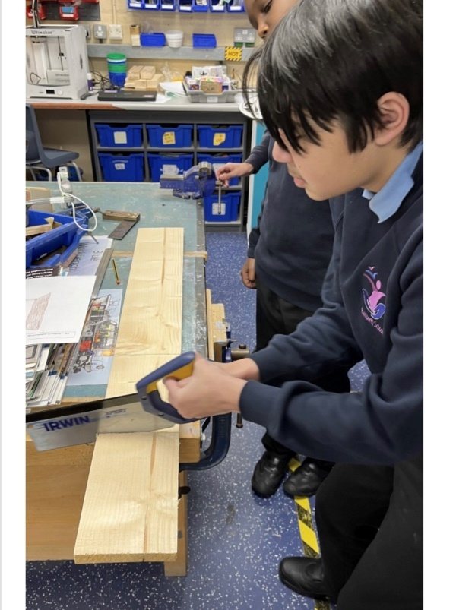Our academic provision runs in Key Stages and then as strands according to student needs; the differing curricula provide excellent opportunities for all students to reach their potential across the full range of their needs, including SMSC. All students access appropriate external accreditation at the end of KS4 and during KS5 in our Sixth Form, and our accreditation offer includes a wide range of GCSEs, Functional Skills, ASDAN, BTEC, and Entry Level Certification, dependent upon student ability.

In Year 7, students have a more class-based curriculum with their class teacher delivering the majority of their learning within a “Foundation Year” setting. Year 7 students also access specialist rooms and may be taught by other staff for lessons such as Forest School, Art, Music, PE, Science, ICT, and Design Technology.

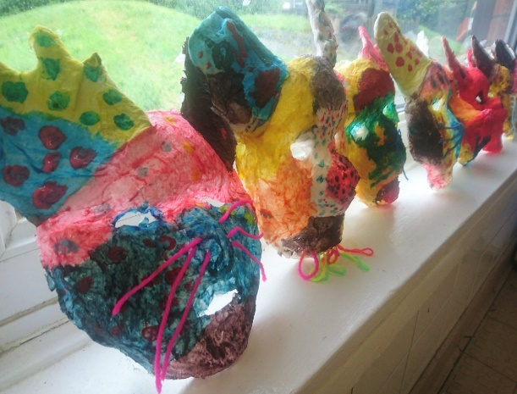From Years 8 to 11, students then follow a differentiated curriculum model, according to their needs:-

* Some follow a more formal curriculum with a

modified mainstream approach

* Some have less transition and spend more time on the consolidation of basic skills
* Some have particular SLD / ASD / SEMH needs

and benefit from smaller groups at times

Students may have support from other professionals, who

work collaboratively with our form team staff.

During KS5 in our Sixth Form, students follow the most suitable curriculum pathway for their ability, and we then offer a Year 14 Transition Year which further supports our students towards an appropriate post-19 destination, which may which may be LifeBridge - the Post-19 setting that was developed a number of years ago by current and retired members of our Senior Leadership Team.

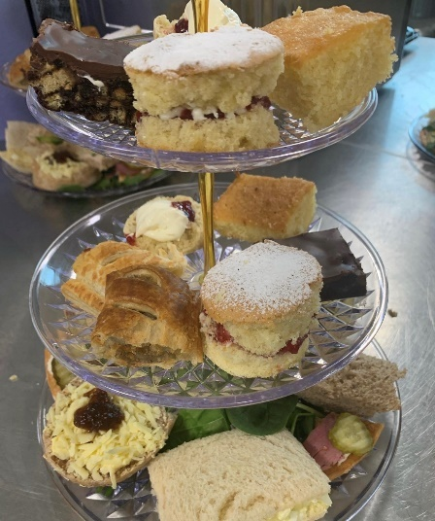We have made significant investments in our vocational facilities and in our curriculum offer to support & promote opportunities for employability, independence and enrichment.

“Rummies” Bistro is open daily and Sixth Form students are involved in preparing and serving a wide range of drinks, snacks and meals, including barista coffees and our renowned cakes and afternoon teas.

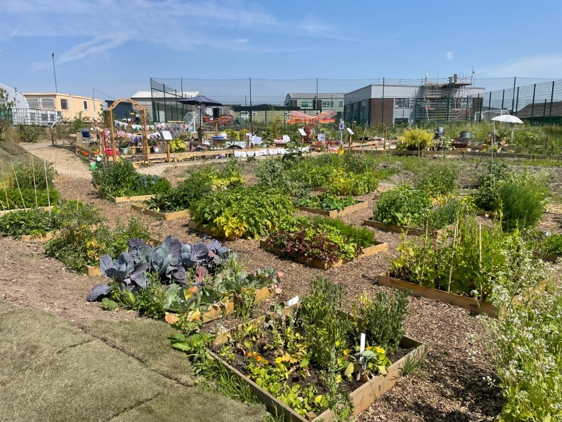

The recent extensive development of our outdoor “Growing Places” area includes a new outdoor classroom area, an industrial-scale growing polytunnel and planting areas with raised beds. Every form class has a small outdoor garden and then each year group takes part in designing an annual ‘show garden’ as part of the Rumworth School Grand Show competition.

The Forest School area, our large fishing lake, accessible outdoor trail paths, the outdoor gym and two outdoor multi-use games areas (MUGAs) all offer secure outdoor spaces to promote health and well-being. Students have the opportunity to develop new skills and access team building activities which support the holistic development of confidence and communication. Students are also taught to swim and have access to therapy sessions in our hydrotherapy pool which has a wave function, and sound & light facilities.

