**Rumworth School**

**Permanent Teacher of English**

**Required as soon as possible**

**Salary Range: M1 to M9 (£31,650 - £49,084)**

**plus SEN Allowance (£5,285, or £2,679 for ECT)**

Rumworth School is a highly regarded Local Education Authority maintained special school in Bolton with an excellent reputation for providing an outstanding provision for all students. Visitors to our school always comment on the “lovely feeling and buzz” and the calm & purposeful learning environment. We currently cater for a range of learning difficulties and additional needs for 340 students, with a planned building expansion programme to offer 400 places. Our students are aged 11-19 and they all have an EHCP because they have a range of SEND which may include: Moderate and Severe Learning Difficulties, Complex Needs, Autistic Spectrum Conditions, Hearing and Visual Impairment, Physical Disability and Social, Emotional and Mental Health Needs. What our students most definitely do all have is a wonderful sense of fun, a love of learning, a high regard for each other and the adults who work with them, and they can’t wait to meet you!

We are seeking to recruit an exceptional and innovative permanent Teacher of English to join our staff as a form teacher in either KS3, KS4 or KS5. As we have a degree of internal flexibility within our talented Faculty teams, please outline in your letter of application the specialist subjects that you are most keen to offer, together with an indication of the ages, abilities and SEND needs that your skills and experience would be most suited to. All form teachers are part of a strong pastoral structure and teach their form class for some of their timetable. We then have five Faculties which are English, Maths, Science & Technology, Arts & Humanities, and Preparation for Adulthood which incorporates Sport & Active Leisure, DofE plus subjects that contribute towards Employability & Independence. As we are a special school, some staff prefer to teach subjects from more than one Faculty, across a range of abilities, SEND needs and ages. This post is payable at M1 to M9, dependent upon your experience, together with an annual SEN allowance of £4,703 (£2,384 for an ECT).

Our ethos is “Start with the young person” therefore you will be a champion for education as the vehicle to improve the life chances and outcomes for our students. Our vision is “You can do it, we will help” - in order to meet the needs of our students, we do have small teaching group sizes and high adult to student ratios. As a form teacher within Key Stage 3, you will embody our philosophy of supporting young people to be more “Confident, Resilient and Independent” through our rich offer of wider life experiences and activities.

Year 7 operates as a “Foundation Year” where students have a more class-based transition from their primary school with the Year 7 team delivering the majority of learning. Year 7 students also access specialist rooms including our dedicated Science laboratories, and they are taught by specialist subject teachers for lessons such as Science, Design Technology, Forest School, Art, Music, PE and ICT.

Students in Years 8 to 11 then follow a differentiated curriculum model, according to their needs:-

* Some follow a more formal curriculum with a modified mainstream approach
* Some have less transition and spend more time on the consolidation of basic skills in a based class

All students access appropriate external accreditation at the end of KS4 and during KS5, and our full accreditation offer includes GCSEs, ASDAN, BTEC, Functional Skills and Entry Level Certification, dependent upon subject and student ability. In KS5, students continue to follow the most suitable curriculum for their ability. We offer a Year 14 Transition where some students continue on to the “Pathway to Employment” route, and those with SLD and complex needs would usually follow a “Pathway to Independence” route.

We are always keen to recruit staff of the highest calibre, and what matters most to us is that you are the “right fit” for our students and our staff. We welcome applications from teachers with relevant primary training & experience, as well as those with SEND experience.

**Visits to our school:**

Visits are strongly recommended prior to application, as this is helpful when tailoring a letter of application in order to evidence how you best meet the selection criteria. Please do not send a generic letter or a CV with your application.

Please contact our School Office on 01204 333600 in order to arrange a visit.

**How to apply:**

Please download and complete the application form and outline your suitability for this post at Rumworth School in your letter of application, within a maximum of two sides of A4 paper.

This post is also advertised on the “Current Vacancies” tab on our school website, which you can view at: www.rumworth.co.uk/current-vacancies.html

All applications should please be returned electronically to Mrs Marsha Andrews, the Headteacher’s PA: mandrews@rumworth.bolton.sch.uk

**Closing date:** 9:00am on Tuesday 7th January 2025

**Shortlisting:** Wednesday 8th January 2025

Shortlisted candidates to be informed by 4:00 pm on Wednesday 8th January 2025

**Interview Date:** Monday 13th January 2025, timings to be confirmed

We are committed to safeguarding and promoting the welfare of children and young people, therefore as part of our Safer Recruitment process, references will be requested for all shortlisted applicants. Appointments are also subject to the outcome of an enhanced DBS check.

Rumworth School, Armadale Road, Bolton BL3 4TP

Telephone: 01204 333600

**Rumworth School**

**General Teacher**

**Applicant Information Pack**

|  |  |
| --- | --- |
| **Our Ethos** | **START WITH THE YOUNG PERSON** |
| **Our Vision** | **‘YOU CAN DO IT, WE WILL HELP’**  Supporting young people to be more  Confident, Resilient, Independent |
| **Our Inclusion Principles** | **EQUALLY DIFFERENT, DIFFERENTLY EQUAL**  At Rumworth, everyone is valued and welcomed as belonging to our school community. Difference and diversity are accepted and nurtured  as contributing to all our achievements. We foster participation and  mutual respect as part of everyday life in our school |
| **Our Mission** | We believe that everything we do should start with the young person.  For them, we aim to create a happy, safe and effective learning community, in which all stakeholders are valued. We aim to provide our students with a wealth of learning opportunities which will not only give them an enriching school experience, but will also equip our students with the skills to give every young person the chance to progress smoothly towards a life of opportunity. |

**Rumworth School**

**General Teacher**

**MPS / UPS plus SEN Allowance £5,285 (£2, 679 ECT)**

**Permanent post**

**Job Description**

The postholder will be a suitably experienced primary-trained General Teacher who will also work as a form teacher in KS3. Teachers at Rumworth School make the education of their students their first concern, and are accountable for achieving the highest possible standards in their work and conduct. Our teachers act with honesty and integrity; have strong subject knowledge, keep their knowledge and skills as teachers up-to-date and are self-critical; forge positive professional relationships; and work with parents and carers in the best interests of their students.

**Purpose of the Job**

Under the reasonable direction of the Headteacher, to carry out the professional duties of a teacher as set out in the School Teachers’ Pay and Conditions Document (STPCD).

To provide the highest quality of education, care and preparation for life for all students in accordance with the Teachers’ Standards which are set out below for both Teaching and Personal & Professional Conduct:

**A) Teaching**

**1. Set high expectations which inspire, motivate and challenge students:**

• establish a safe and stimulating environment for students, rooted in mutual respect

• set goals that stretch and challenge students of all backgrounds, abilities and dispositions

• demonstrate consistently the positive attitudes, values and behaviour which are expected of students.

**2. Promote good progress and outcomes by students:**

• be accountable for students’ attainment, progress and outcomes

• be aware of students’ capabilities and their prior knowledge, and plan teaching to build on these

• guide students to reflect on the progress they have made and their emerging needs

• demonstrate knowledge and understanding of how students learn and how this impacts on teaching

• encourage students to take a responsible and conscientious attitude to their own work and study.

**3. Demonstrate good subject and curriculum knowledge:**

• have a secure knowledge of the relevant subject(s) and curriculum areas, foster and maintain students’ interest in the subject, and address misunderstandings

• demonstrate a critical understanding of developments in the subject and curriculum areas, and promote the value of scholarship

• demonstrate an understanding of and take responsibility for promoting high standards of literacy, articulacy and the correct use of standard English, whatever the teacher’s specialist subject

• if teaching early reading, demonstrate a clear understanding of systematic synthetic phonics

• if teaching early mathematics, demonstrate a clear understanding of appropriate teaching strategies.

**4. Plan and teach well-structured lessons:**

• impart knowledge and develop understanding through effective use of lesson time

• promote a love of learning and children’s intellectual curiosity

• set homework and plan other out-of-class activities to consolidate and extend the knowledge and understanding students have acquired

• reflect systematically on the effectiveness of lessons and approaches to teaching

• contribute to the design and provision of an engaging curriculum within the relevant subject area(s).

**5. Adapt teaching to respond to the strengths and needs of all students:**

• know when and how to differentiate appropriately, using approaches which enable students to be taught effectively

• have a secure understanding of how a range of factors can inhibit students’ ability to learn, and how best to overcome these

• demonstrate an awareness of the physical, social and intellectual development of children, and know how to adapt teaching to support students’ education at different stages of development

• have a clear understanding of the needs of all students, including those with special educational needs; those of high ability; those with English as an additional language; those with disabilities; and be able to use and evaluate distinctive teaching approaches to engage and support them.

**6. Make accurate and productive use of assessment:**

• know and understand how to assess the relevant subject and curriculum areas, including statutory assessment requirements

• make use of formative and summative assessment to secure students’ progress

• use relevant data to monitor progress, set targets, and plan subsequent lessons

• give students regular feedback, both orally and through accurate marking, and encourage students to respond to the feedback.

**7. Manage behaviour effectively to ensure a good and safe learning environment:**

• have clear rules and routines for behaviour in classrooms, and take responsibility for promoting good and courteous behaviour both in classrooms and around the school, in accordance with the school’s behaviour policy

• have high expectations of behaviour, and establish a framework for discipline with a range of strategies, using praise, sanctions and rewards consistently and fairly

• manage classes effectively, using approaches which are appropriate to students’ needs in order to involve and motivate them

• maintain good relationships with students, exercise appropriate authority, and act decisively when necessary.

**8. Fulfil wider professional responsibilities:**

• make a positive contribution to the wider life and ethos of the school

• develop effective professional relationships with colleagues, knowing how and when to draw on advice and specialist support

• deploy support staff effectively

• take responsibility for improving teaching through appropriate professional development, responding to advice and feedback from colleagues

• communicate effectively with parents and carers with regard to students’ achievements and well-being.

**B) Personal & Professional Conduct**

Teachers at Rumworth School are expected to demonstrate consistently high standards of personal & professional conduct. The following statements from the Teachers’ Standards define the behaviour and attitudes which set the required standard for conduct throughout a teacher’s career:

1. Teachers uphold public trust in the profession and maintain high standards of ethics and behaviour, within and outside school, by:

• treating pupils with dignity, building relationships rooted in mutual respect, and at all times observing proper boundaries appropriate to a teacher’s professional position

• having regard for the need to safeguard pupils’ well-being, in accordance with statutory provisions

• showing tolerance of and respect for the rights of others

• not undermining fundamental British values, including democracy, the rule of law, individual liberty and mutual respect, and tolerance of those with different faiths and beliefs

• ensuring that personal beliefs are not expressed in ways which exploit pupils’ vulnerability or might lead them to break the law.

2. Teachers must have proper and professional regard for the ethos, policies and practices of the school in which they teach, and maintain high standards in their own attendance and punctuality.

3. Teachers must have an understanding of, and always act within, the statutory frameworks which set out their professional duties and responsibilities.

**Relationships**

The postholder is ultimately responsible to the Headteacher for their teaching duties and responsibilities and for teaching tasks.

Line management and performance management responsibilities are delegated by the Headteacher in accordance with Rumworth School’s structures.

The postholder is responsible for liaison with support services and other outside agencies as appropriate.

The postholder is responsible for the supervision of the work of Additional Support staff relevant to their responsibilities.

**Applicable Contract Terms and Duties**

This job description is to be performed in accordance with the provisions of the School Teachers’ Pay and Conditions Document (STPCD) and within the range of duties set out in that document so far as relevant to the postholder’s title and salary grade. The post is otherwise subject to the Conditions of Service for School Teachers in England and Wales (the ‘Burgundy Book’) and Teachers’ Standards, and to locally agreed conditions of employment to the extent that they are incorporated in the postholder’s individual contract of employment. Copies of the relevant documents are available for inspection at Rumworth School.

(This is not a comprehensive list of all responsibilities and tasks which may be required of the postholder. It is illustrative of the general nature and level of responsibility of the work to be undertaken, commensurate with the grade. This job description may be amended at any time in consultation with the postholder.)

Review Date:

Headteacher: Date:

Postholder: Date:

Job Description updated by Caroline Dawson & Sarah Roberts, Deputy Headteachers at Rumworth School, March 2024

**Rumworth School**

|  |  |  |  |
| --- | --- | --- | --- |
| Person Specification General Teacher  MPS / UPS plus SEN Allowance £5,285 (£2,679 for an ECT) | Essential | Desirable | * A / I / R |
| QUALIFICATIONS | | | |
| UK Qualified Teacher Status | 🗸 |  | A |
| Relevant teaching qualification | 🗸 |  | A |
| Relevant degree with a minimum of 2:2 or equivalent qualification | 🗸 |  | A |
| Relevant specialist subject qualification |  | 🗸 | A |
| Relevant specialist SEND qualification |  | 🗸 | A |
| Recent participation in relevant training |  | 🗸 | A |
| PROFESSIONAL EXPERIENCE | | | |
| Excellent experience as an inspirational teacher | 🗸 |  | A R |
| Excellent teaching experience in more than one school |  | 🗸 | A R |
| Successful experience of developing relevant subject planning |  | 🗸 | A I R |
| Experience of managing resources efficiently and effectively | 🗸 |  | A I R |
| Effective monitoring & tracking of student progress and attainment | 🗸 |  | A I R |
| Experience of leading an innovation through to successful implementation |  | 🗸 | A I R |
| KNOWLEDGE & UNDERSTANDING | | | |
| An understanding of the characteristics of an effective special school | 🗸 |  | A I |
| A sound knowledge and understanding of, or willingness to learn about, the current educational issues affecting special schools | 🗸 |  | A I |
| Knowledge and understanding of, or willingness to learn about, the impact of SEND on learning and behaviour and how this influences pedagogy | 🗸 |  | A I |
| An understanding of appropriate strategies for managing student behaviour | 🗸 |  | A I |
| An understanding of the effective use of AoL and AfL, including setting suitable targets, robust data tracking, moderation, marking and feedback | 🗸 |  | A I |
| An awareness of inclusion in its wider sense, including the needs of those from different ethnic backgrounds | 🗸 |  | A I |
| PERSONAL QUALITIES & SKILLS | | | |
| Enthusiasm, drive and a love for the job | 🗸 |  | A I |
| Personal impact and positive presence | 🗸 |  | A I |
| Ability to foster an open culture where all are valued and treated fairly | 🗸 |  | A I |
| Excellent communication skills, both verbal and written | 🗸 |  | A I |
| Competent in the use of ICT | 🗸 |  | A I |
| Creativity in problem-solving situations | 🗸 |  | A I |
| Able to deal sensitively with people and resolve conflict effectively | 🗸 |  | A I |
| Excellent attendance and punctuality record | 🗸 |  | A I |
| A good sense of humour | 🗸 |  | A I |
| Flexibility, adaptability and approachable | 🗸 |  | A I |
| Resilience under pressure | 🗸 |  | A I |

* A Application I Interview R Reference

**General Information about Rumworth School**

This positive and successful secondary special school is ambitious, high-achieving, supportive and happy; the school ensures that the impact is high on improvement for all of our students, who are at the heart of everything we do. We have 340 students in 35 classes across Years 7 to 14, and next academic year this will increase to 36 classes as we are continuing to expand towards offering 400 places. We are undergoing a further building programme to accommodate this planned growth, which will further enhance the space and wide range of facilities available on our site in order to offer an appropriate secondary special school curriculum for our students who have a wide range of SEND.

Staff work in close partnership with parents and other professionals to ensure we offer a broad, relevant curriculum which builds on objectives recorded in EHCPs and takes account of the full range of the interests, needs and aspirations of our students. Governors, parents and staff are very supportive of the school and responses in surveys are overwhelmingly positive. All staff embody our vision of "You can do it, we will help".

Our Shared Vision is integrated into all aspects of school development and evaluation, and it is the vehicle by which we strive to deliver those commitments we made to our children and young people and everyone in our community. The Senior Leadership Team and the Governing Body have high expectations for what all of our students can achieve, whilst seeking to ensure they become more "Confident, Resilient and Independent". We work collaboratively with our senior middle leaders and middle leaders who make up the Extended Leadership Team, and also with all staff in order to ensure high standards of provision and care for students.

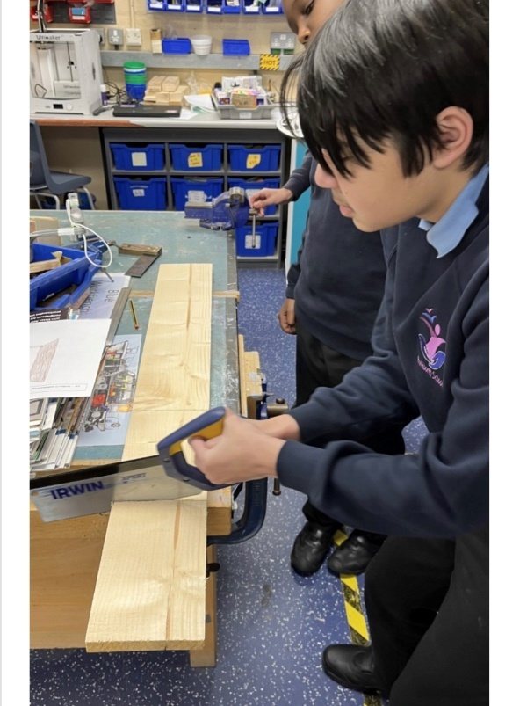Our academic provision runs in Key Stages and then as strands according to student needs; the differing curricula provide excellent opportunities for all students to reach their potential across the full range of their needs, including SMSC. All students access appropriate external accreditation at the end of KS4 and during KS5 in our Sixth Form, and our accreditation offer includes a wide range of GCSEs, Functional Skills, ASDAN, BTEC, and Entry Level Certification, dependent upon student ability.

In Year 7, students have a more class-based curriculum with their class teacher delivering the majority of their learning within a “Foundation Year” setting. Year 7 students also access specialist rooms and may be taught by other staff for lessons such as Forest School, Art, Music, PE, Science, ICT, and Design Technology.

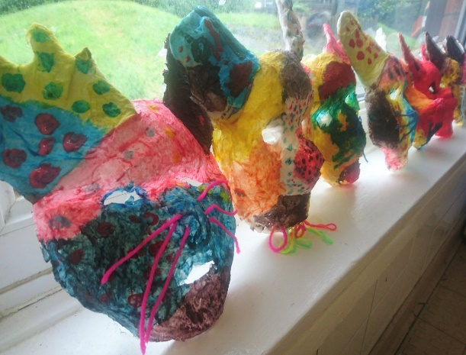In Years 8 to 11, students then follow a differentiated curriculum model, according to their needs:-

* Some follow a more formal curriculum with a

modified mainstream approach

* Some have less transition and spend more time on the consolidation of basic skills
* Some have particular SLD / ASD / SEMH needs

and benefit from smaller groups at times

Students may have support from other professionals, who

work collaboratively with our form team staff.

During KS5 in our Sixth Form, students follow the most suitable curriculum for their ability, and we then offer a Year 14 Transition; some continue on to the “Pathway to Employment” route, and those with more severe learning difficulties and complex needs would usually follow a “Pathway to Independence” route. Students then transition to an appropriate post-19 destination, which may be LifeBridge which is the Post-19 setting that was developed by current and retired members of our Senior Leadership Team.

We have made significant investments in our vocational facilities and in our curriculum offer to support & promote employability and independence. Our “Rummies” Bistro is open daily and students are involved in preparing and serving a wide range of drinks, snacks and meals, including barista coffees and our renowned afternoon teas and cakes.

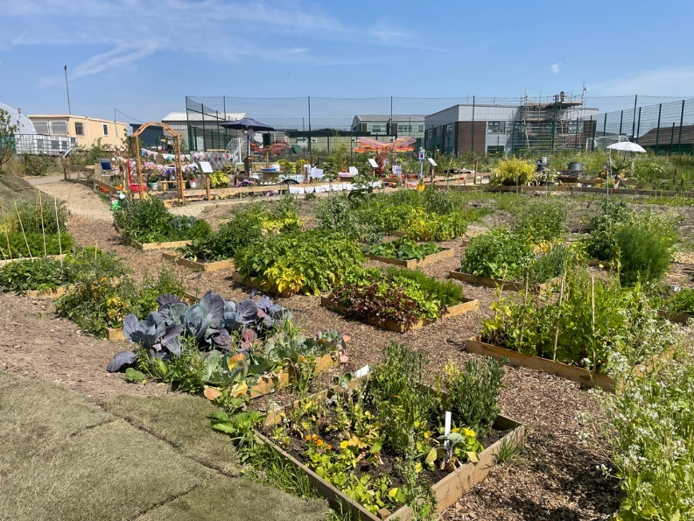

The recent extensive development of our outdoor “Growing Places” area includes a new outdoor classroom area, an industrial-scale growing polytunnel and planting areas with raised beds. Every form class has a small outdoor garden and then each year group takes part in designing an annual ‘show garden’ as part of the Rumworth School Grand Show competition.

The Forest School area, our large fishing lake, accessible outdoor trail paths, the outdoor gym and two outdoor multi-use games areas (MUGAs) all offer secure outdoor spaces to promote health and well-being. Students have the opportunity to develop new skills and access team building activities which support the holistic development of confidence and communication. Students are also taught to swim and have access to therapy sessions in our hydrotherapy pool which has a wave function, and sound & light facilities.

